**Lexar® Professional CFexpress™ Type A Card GOLD Series**

320GB

160GB

80GB

[Where to buy](https://americas.lexar.com/product/lexar-professional-cfexpress-type-a-card-gold-series/)

**Key Features:**

**Up to 900MB/s read, 800MB/s write speeds**

**Sustained write speeds of 700 MB/s**

* High-Speed Performance
* Seamless Video Capture
* With VPG400 Support
* For Professional Users

**Key Features:**

**Up to 900MB/s read, 800MB/s write speeds**

**Sustained write speeds of 700 MB/s**

* High-Speed Performance
* Seamless Video Capture
* With VPG400 Support
* For Professional Users

**Key Features:**

**Up to 900MB/s read, 800MB/s write speeds**

**Sustained write speeds of 700 MB/s**

* High-Speed Performance
* Seamless Video Capture
* With VPG400 Support
* For Professional Users

**Key Features:**

**Up to 900MB/s read, 800MB/s write speeds**

**Sustained write speeds of 700 MB/s**

* High-Speed Performance
* Seamless Video Capture
* With VPG400 Support
* For Professional Users

[Features](https://americas.lexar.com/product/lexar-professional-cfexpress-type-a-card-gold-series/#feature-section)[Specifications](https://americas.lexar.com/product/lexar-professional-cfexpress-type-a-card-gold-series/#specifications)[Part Numbers](https://americas.lexar.com/product/lexar-professional-cfexpress-type-a-card-gold-series/#product-numbers)[Related products](https://americas.lexar.com/product/lexar-professional-cfexpress-type-a-card-gold-series/#related-products)

**Features**

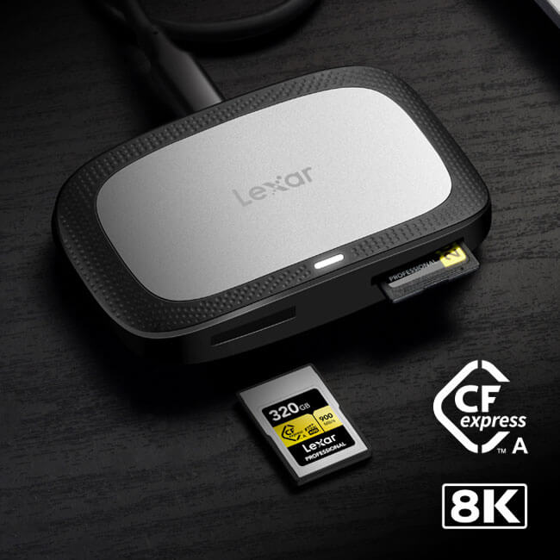

**Superior Performance to Capture Cinema–Quality 8K Video**

With superior speed up to 900MB/s,¹ write speed up to 800MB/s,¹ and Video Performance Grade 400 (VPG400), you can capture with confidence knowing you’ll never miss a frame.

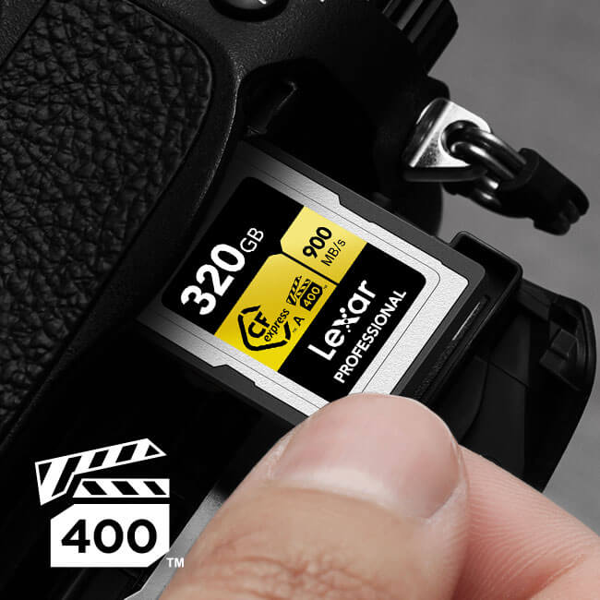

**Sustained Speed for Seamless Video**

Rated Video Performance Guarantee 400 (VPG400), the Lexar® Professional CFexpress™ Type A Card Gold Series meets a minimum write speed of 700 MB/s.1 This guarantees that your content is captured seamlessly with no dropped frames.



**Capture Adventure with Ultimate Durability**

These cards provide the performance you need to capture and store valuable data in a variety of elements. The Lexar® Professional CFexpress™ Type A Card GOLD Series delivers the rugged durability you need to protect from temperature, shock, and vibration.2

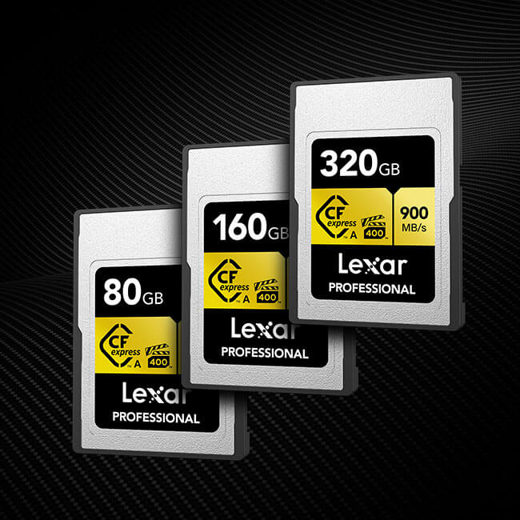

**Large Capacity Options**

Available in capacities up to 320GB, you can capture more high-quality images and cinema-quality 8K video without needing to constantly swap cards.

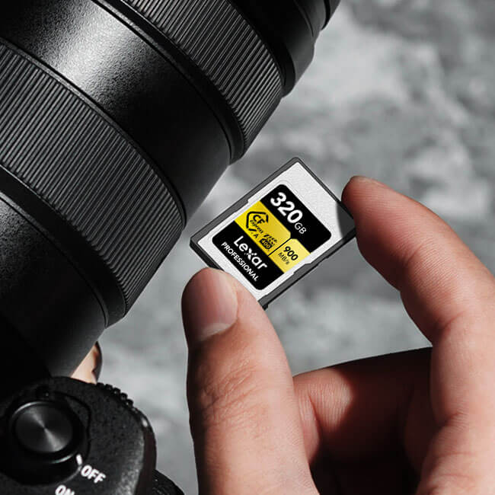

**Warranty and Support**

All Lexar Professional line memory cards come with a limited lifetime warranty³and are backed by expert technical support.

**Rigorously Tested**

All Lexar products undergo extensive testing in the Lexar Quality Labs, facilities with thousands of different cameras and digital devices to ensure performance, quality, compatibility, and reliability.

**Specifications**

* Capacity

320GB | 160GB | 80GB

* Form Factor

CFexpress™ Type A

* Interface

PCI Express®

* Performance

Up to 900MB/s read, 800MB/s write speeds1

* Sustained Write Speed

700 MB/s

* Operating Temperature

-10°C ~ 70°C (14°F ~ 158°F)2

* Storage Temperature

-25°C ~ 85°C (-13°F ~ 185°F)

* Warranty

Limited-lifetime warranty³

* Video Class

VPG400